**FINANCIAL ACTIVITY OF AGRICULTURAL LAND**

**Project By: Syed Muhammad Zaid**

ABSTRACT / Executive Summary

The whole process of financial activity is manual. The idea is to semi-automate the financial activity of agricultural land by entering calculations on system and to generate a system generated calculations with record. In future work it will be more helpful for accurate calculations and to keep their record for fetching. The whole process of financial activity of agricultural land will be in digitalize form if all the stakeholders agree to digital payment system.

.

**Table of Contents:**

**Figure 7.1 (Swim-lane Diagram) …...................................................................................... 12**

**Figure 7.2 (Context Diagram) ............................................................................................... 13**

**Figure 8.1(Use Case Diagram) ….......................................................................................... 14**

**Figure 8. 2(Object Diagram) ................................................................................................. 51**

**Figure 8. 3.1 (Sequence Diagram Ag-1) ............................................................................... 52**

**Figure 8. 3.2 (Sequence Diagram Ag-2) ................................................................................. 5**

**Figure 8. 3.3 (Sequence Diagram Ag-3) ............................................................................... 54**

**Figure 8. 3.4 (Sequence Diagram Ag-5) ................................................................................55**

**Figure 8. 3.5 (Sequence Diagram Ag-7) ............................................................................... 56**

**Figure 8. 3.6 (Sequence Diagram Ag-13) ............................................................................. 57**

**Figure 8. 3.7 (Sequence Diagram Ag-14) ............................................................................. 58**

**Figure 8. 3.8 (Sequence Diagram Ag-15 (a) ......................................................................... 59**

**Figure 8. 3.9 (Sequence Diagram Ag-15 (b) ........................................................................ 60**

**Figure 8. 3.10 (Sequence Diagram Ag-16) ........................................................................... 61**

**Figure 8. 4 (Class Diagram) .................................................................................................. 6**2

**Introduction and Overview**

It’s about a small business of agricultural land working manually. They have four members Owner, Middleman, Partner and Assistant.

Owner: He owns the agricultural land and hires the assistant and partner and provides machinery, seeds, fertilizers and medicines to partner.

Middleman: He provides loan and necessities of living to owner and buy the crops from owner.

Partner: He is a labor and takes payment when crops are sold.

Assistant: He maintains the record of loan and facilities provided to partner and the loan given by middleman.

It’s their family business which is centuries old and working manually which we have semi-automated and removed the assistant because now the system maintains the whole record. They avoid automated payment methods that’s why this business exists with middleman. If they agree on banking payment channel than there will be no need of middleman and they will directly interact with government and there will be no need of middleman.

**BACKGROUND**

This system of agricultural land was working manually when partner and assistant comes at owner’s place to request for job, land, seeds, fertilizers and machinery. Assistant manually records the loan and calculations where an error can be occurred.

**AIM AND STATEMENT OF PROBLEM**

The Scope is to make the financial activity of agricultural land semi-automated and the procedure of making request/ granting permission to one another automated. Nowadays they keep record of financial activity manually and request to one another by going at the place of others that is time consuming so that now they can record on database and ask to each other through system.

**METHODS, ASSUMPTIONS, and PROCEDURES**

**Structured Methodology Overview**

Structured systems analysis and design methodology (SSADM) is a set of standards for systems analysis and application design. It uses a formal methodical approach to the analysis and design of information systems. ... The SSADM is an open methodology based on the waterfall model.

**Advantages Lower Costs**

TQM lowers costs throughout the business infrastructure and organization. Because it is an all-encompassing quality management program, TQM helps different people to communicate their needs, problems, and desires with each other, so that workable solutions can be found that will help the organization cut costs throughout the supply chain, distribution chain, shipping and receiving, accounting and management departments without losing productivity or the ability to operate rapidly in the face of change.

The concept of Total Quality Management is rooted in the idea of providing all of the tools, training, and experience necessary to measure the entire quality control of an organization.

**Improved Reputation**

TQM programs have the advantage of improving corporate as well as product reputations in the marketplace, because errors and defective calculations are discovered much more rapidly than under a non-TQM system, and often before they are ever sent to market or found in the hands of the public.

**Disadvantages Resistance to Change**

Stakeholders may feel that their occupations within the business are at risk under a comprehensive TQM program, and as a result, they may be slow or resistant to making the necessary changes for the TQM program to work properly. In addition, skilled workers may be lost as they decide to leave because of their unease at the direction that things are headed within the business, or they may not implement things properly, causing increased costs.

**High Cost of Time**

The high cost of implementing a TQM program, and the fact that it may take several years for the program to be fully implemented before results and benefits are seen, can be a huge disadvantage to a TQM program, especially in today's uncertain economic conditions. TQM should be considered a long-term investment.

**Information Engineering Methodology Overview**

Information engineering is a family of data-oriented analysis and techniques used to design, develop, and maintain information systems which support strategic missions, decision processes, and daily operations of a company. It is often regarded as a data-oriented methodology rather than a process-oriented methodology.

**Advantages**

The primary advantage of the IE methodology is that data are identified first, then the functions are identified second. The IE methodology does not foster the complete decomposition of the inputs, processes, and outputs. In fact it can be argued that IE does not hierarchically decompose the functions in the same way that the traditional methodologies do; this can be seen as an advantage not to have to train users to decompose the functionality of the system.

**Disadvantages**

The disadvantages of the IE methodology include the fact that users must be trained to understand the models and that users must be able to identify the data of the system first before identifying the functions of the system.

**Object Oriented Methodology Overview**

Object-oriented (O-O) analysis and design is an approach that is intended to facilitate the development of systems that must change rapidly in response to dynamic business environments. ... Each object is a computer representation of some actual thing or event. Objects may be owner, partner, middleman, and so on

**Advantages**

Focuses on data rather than the procedures as in Structured Analysis. The principles of encapsulation and data hiding help the developer to develop systems that cannot be tampered by other parts of the system. The principles of encapsulation and data hiding help the developer to develop systems that cannot be tampered by other parts of the system. It allows effective management of software complexity by the virtue of modularity.

**Disadvantages**

Functionality is restricted within objects. This may pose a problem for systems which are intrinsically procedural or computational in nature. It cannot identify which objects would generate an optimal system design. The object-oriented models do not easily show the communications between the objects in the system. All the interfaces between the objects cannot be represented in a single diagram.

**AVAILABLE RELEVANT SOLUTIONS AND EVALUATION**

Easy Khata App

**Link (** [**https://www.easykhata.in/ HYPERLINK "https://www.arniesoftware.com/"**](https://www.easykhata.in/%20HYPERLINK%20%22https://www.arniesoftware.com/%22) **)**

On this app you can easily record your digital transactions record.

**DigiKhata App**

**Link (** [**https://www.digikhata.pk/ HYPERLINK "https://www.arniesoftware.com/"**](https://www.digikhata.pk/%20HYPERLINK%20%22https://www.arniesoftware.com/%22) **)**

On this app you can easily record your digital transactions record.

These are the solutions available but they needed a system where with record keeping they can make requests which is now available on our financial activity software.

**ANALYSIS AND DESIGN**

Workflow Diagram/ Swimlane (Financial Activity of Agricultural Land)

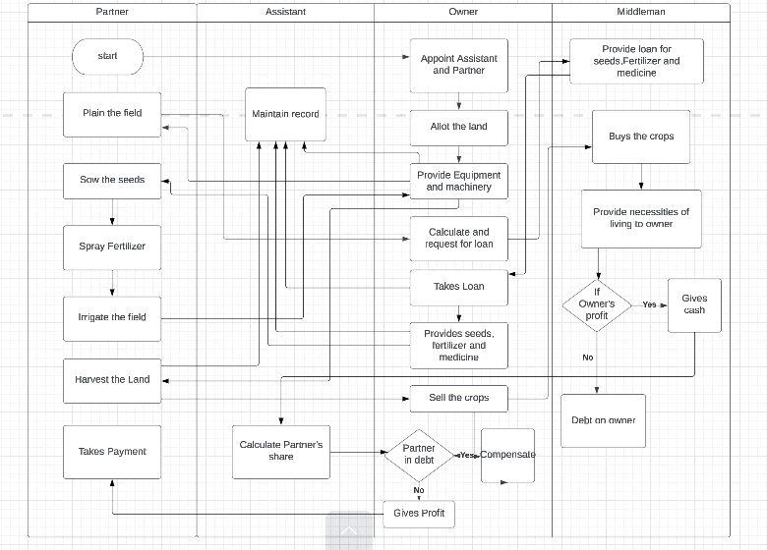

**fIGURE 7.1: Swimlane Diagram**

In the above figure first partner and assistant will come to owner for a job than after hiring them owner will allot the land and provide equipment and machinery assistant will record it and partner will plain the field than owner calculates and request for loan. Middleman provides loan owner takes that loan and provide seeds fertilizers and medicines to partner which assistant will maintain in the record and partner will sow the seed, spray fertilizers and irrigate the field than he will again request for machinery which owner will provide him so that he can harvest the land which will be maintained in record by assistant and owner will sell the crops and middleman will buy the crops and provide necessities of living to owner than he will take decision that owner is in deficit or profit if he is in profit than he will give cash from which assistant will calculate partner’s share and owner will take decision that if partner is in deficit than compensate otherwise gives profit to partner.

**Context diagram:**

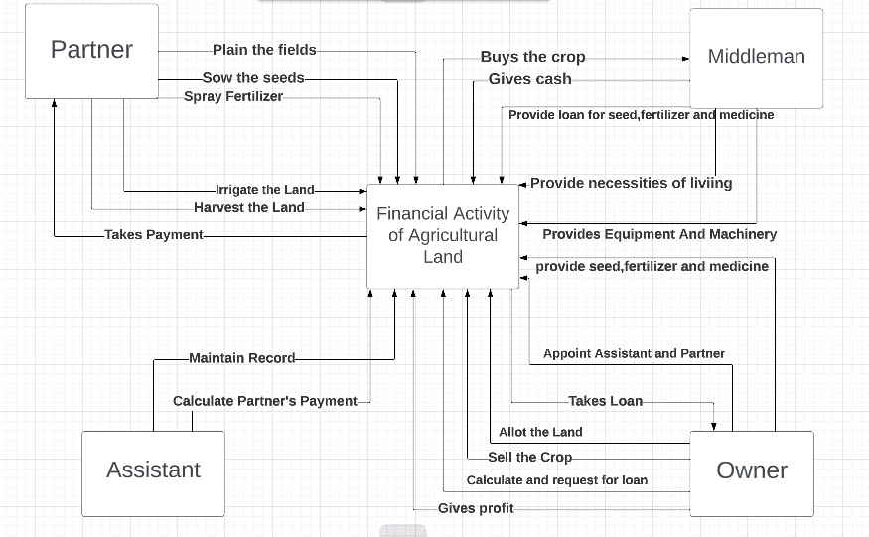

**Figure 7.2 (Context Diagram)**

In the above figure first partner and assistant will come to owner for a job than after hiring them owner will allot the land and provide equipment and machinery assistant will record it and partner will plain the field than owner calculates and request for loan. Middleman provides loan owner takes that loan and provide seeds fertilizers and medicines to partner which assistant will maintain in the record and partner will sow the seed, spray fertilizers and irrigate the field than he will again request for machinery which owner will provide him so that he can harvest the land which will be maintained in record by assistant and owner will sell the crops and middleman will buy the crops and provide necessities of living to owner than he will take decision that owner is in deficit or profit if he is in profit than he will give cash from which assistant will calculate partner’s share and owner will take decision that if partner is in deficit than compensate otherwise gives profit to partner.

**Use-case diagram:**

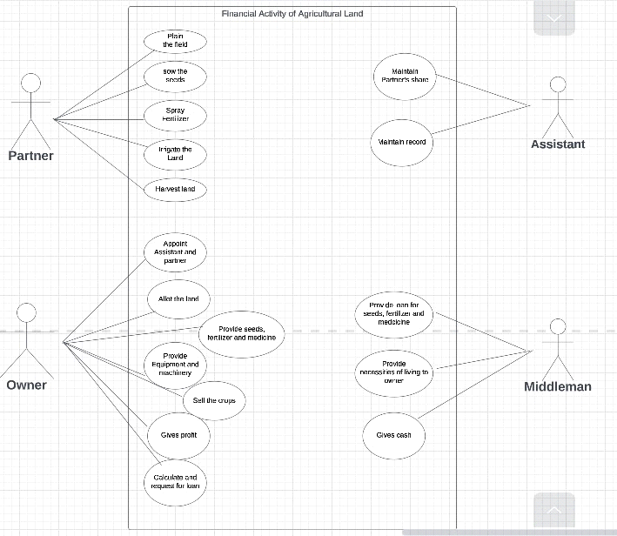

**Figure 8.1 (Use Case Diagram)**

The above figure represents the initiation of actors, where middleman is providing loan, necessities and cash to owner. Assistant is maintaining record and Calculates partner’s share. Whereas partner plains the field, sow the seeds, spray fertilizers, irrigate the land and harvest the land. Owner appoints assistant and partner, allot the land, calculates and requests for loan, provide machinery and seeds, sell the crops and gives profit.

**Actor Use Case Table**

|  |  |  |  |  |
| --- | --- | --- | --- | --- |
| USECASE | Primary actor | SYSTEM ACTOR | OTHER  PARTICIPATING  ACTOR | OTHER INTERESTED  STAKEHOLDER |
| Appoint assistant and partner | Assistant, Partner | Owner | No | No |

|  |  |  |  |  |
| --- | --- | --- | --- | --- |
| USECASE | Primary actor | SYSTEM ACTOR | OTHER  PARTICIPATING  ACTOR | OTHER INTERESTED  STAKEHOLDER |
| Allot the land | Partner | Owner | No | No |

|  |  |  |  |  |
| --- | --- | --- | --- | --- |
| USECASE | Primary actor | SYSTEM ACTOR | OTHER  PARTICIPATING  ACTOR | OTHER INTERESTED  STAKEHOLDER |
| Provide equipment and machinery | Partner | Owner | Assistant | No |

|  |  |  |  |  |
| --- | --- | --- | --- | --- |
| USECASE | Primary actor | SYSTEM ACTOR | OTHER  PARTICIPATING  ACTOR | OTHER INTERESTED  STAKEHOLDER |
| Plain the Field | Partner | No | No | No |

|  |  |  |  |  |
| --- | --- | --- | --- | --- |
| USECASE | Primary actor | SYSTEM ACTOR | OTHER  PARTICIPATING  ACTOR | OTHER INTERESTED  STAKEHOLDER |
| Calculate and request for loan | Owner | Middleman | No | No |

|  |  |  |  |  |
| --- | --- | --- | --- | --- |
| USECASE | Primary actor | SYSTEM ACTOR | OTHER  PARTICIPATING  ACTOR | OTHER INTERESTED  STAKEHOLDER |
| Provide loan for seeds, fertilizers and medicines. | Middleman | Owner | Assistant | No |

|  |  |  |  |  |
| --- | --- | --- | --- | --- |
| USECASE | Primary actor | SYSTEM ACTOR | OTHER  PARTICIPATING  ACTOR | OTHER INTERESTED  STAKEHOLDER |
| Provide seeds, fertilizers and medicines. | Partner | Owner | Assistant | No |

|  |  |  |  |  |
| --- | --- | --- | --- | --- |
| USECASE | Primary actor | SYSTEM ACTOR | OTHER  PARTICIPATING  ACTOR | OTHER INTERESTED  STAKEHOLDER |
| Sow the seeds | Partner | No | No | No |

|  |  |  |  |  |
| --- | --- | --- | --- | --- |
| USECASE | Primary actor | SYSTEM ACTOR | OTHER  PARTICIPATING  ACTOR | OTHER INTERESTED  STAKEHOLDER |
| Spray fertilizers | Partner | No | No | No |

|  |  |  |  |  |
| --- | --- | --- | --- | --- |
| USECASE | Primary actor | SYSTEM ACTOR | OTHER  PARTICIPATING  ACTOR | OTHER INTERESTED  STAKEHOLDER |
| Irrigate the land | Partner | No | No | No |

|  |  |  |  |  |
| --- | --- | --- | --- | --- |
| USECASE | Primary actor | SYSTEM ACTOR | OTHER  PARTICIPATING  ACTOR | OTHER INTERESTED  STAKEHOLDER |
| Harvest the land | Partner | No | Assistant | No |

|  |  |  |  |  |
| --- | --- | --- | --- | --- |
| USECASE | Primary actor | SYSTEM ACTOR | OTHER  PARTICIPATING  ACTOR | OTHER INTERESTED  STAKEHOLDER |
| Sell the crops | Owner | Middleman | No | No |

|  |  |  |  |  |
| --- | --- | --- | --- | --- |
| USECASE | Primary actor | SYSTEM ACTOR | OTHER  PARTICIPATING  ACTOR | OTHER INTERESTED  STAKEHOLDER |
| Provide Necessities of living to owner | Owner | Middleman | No | No |

|  |  |  |  |  |
| --- | --- | --- | --- | --- |
| USECASE | Primary actor | SYSTEM ACTOR | OTHER  PARTICIPATING  ACTOR | OTHER INTERESTED  STAKEHOLDER |
| Gives Cash | Middleman | Owner | No | Assistant |

|  |  |  |  |  |
| --- | --- | --- | --- | --- |
| USECASE | Primary actor | SYSTEM ACTOR | OTHER  PARTICIPATING  ACTOR | OTHER INTERESTED  STAKEHOLDER |
| Maintains Record | Owner | Assistant | Partner | No |

|  |  |  |  |  |
| --- | --- | --- | --- | --- |
| USECASE | Primary actor | SYSTEM ACTOR | OTHER  PARTICIPATING  ACTOR | OTHER INTERESTED  STAKEHOLDER |
| Calculate Partner’s share | Assistant | Owner | Middleman, Partner | No |

|  |  |  |  |  |
| --- | --- | --- | --- | --- |
| USECASE | Primary actor | SYSTEM ACTOR | OTHER  PARTICIPATING  ACTOR | OTHER INTERESTED  STAKEHOLDER |
| Gives Profit | Owner | Partner | Assistant | No |

**Report Detailed List**

|  |  |
| --- | --- |
| USECASE | Reports |
| Appoint Assistant and Partner | **Detailed**  List of Partners  **Summary**  Terms and Conditions  **Exception**  Dis agree to terms and conditions |
|  |  |

|  |  |
| --- | --- |
| USECASE | Reports |
| Allot the Land | **Detailed**  List of requests by partner  **Summary**  List of properties owned by owner  List of properties allotted to every individual partner. |
|  |  |

|  |  |
| --- | --- |
| USECASE | Reports |
| Provide equipment and machinery | **Detailed**  List of requests by partner  **Summary**  List of equipment provided  **Exception**  Machinery not provided |
|  |  |

|  |  |
| --- | --- |
| USECASE | Reports |
| Plain the field | **Summary**  Primary reports summary of land  **Exception**  Land not plained. |

|  |  |
| --- | --- |
| USECASE | Reports |
| Calculate and request for loan | **Detailed**  List of requests made by owner  **Summary**  Record summary of loan |

|  |  |
| --- | --- |
| USECASE | Reports |
| Provide loan for seeds, fertilizers and medicines | **Summary**  Loan report summary  **Exception**  Loan not provided. |
|  |  |

|  |  |
| --- | --- |
| USECASE | Reports |
| Provide seeds, fertilizers and medicines | **Detailed**  List of loans for seeds, fertilizers and medicines  **Summary**  Items provided summary report. |
|  |  |

|  |  |
| --- | --- |
| USECASE | Reports |
| Sow the seeds | **Summary**  Primary seed sown reports summary of land |
|  |  |

|  |  |
| --- | --- |
| USECASE | Reports |
| Spray fertilizers | **Summary**  Primary fertilizer sprayed report summary of land |

|  |  |
| --- | --- |
| USECASE | Reports |
| Irrigate the land | **Summary**  Damage to land report summary  Land Irrigated report summary |
|  |  |

|  |  |
| --- | --- |
| USECASE | Reports |
| Harvest the Land | **Summary**  Crops harvested summary report |
|  |  |

|  |  |
| --- | --- |
| USECASE | Reports |
| Sell the crops | **Detailed**  List of crops sold  **Summary**  Record summary of crops |

|  |  |
| --- | --- |
| USECASE | Reports |
| Provide Necessities of living to owner | **Summary**  Loan report summary  **Exception**  Loan not provided. |
|  |  |

|  |  |
| --- | --- |
| USECASE | Reports |
| Gives Cash | **Summary**  Cash provided summary report.  **Exception**  Owner in deficit. |
|  |  |

|  |  |
| --- | --- |
| USECASE | Reports |
| Maintains Record | **Detailed**  List of partners  **Summary**  Land allotted summary  Machinery provided summary  Seeds, loan, necessities provided summary  Crops harvested summary report  **Exception**  Crops damage and deficit report |
|  |  |

|  |  |
| --- | --- |
| USECASE | Reports |
| Calculate Partner’s share | **Summary**  Loan provided to partner summary report  Crops sold summary report.  **Exception**  Partner in deficit. |

|  |  |
| --- | --- |
| USECASE | Reports |
| Gives Profit | **Summary**  Profit provided summary report.  **Exception**  Partner in deficit. |
|  |  |

**SYSTEM ANALYSIS AND DESIGN USE CASE DOCUMENTATION**

**Financial Activity of Agricultural Land**

**Author(s): _________________ version: 1.00 ___ Date: ______________**

|  |  |  |
| --- | --- | --- |
| **Use Case Name:** | **Appoint Assistant and Partner** | **Business requirement:**  **System analysis: Yes**  **System design:** |
| **Use Case ID:** | **Ag – 1** |
| **Priority:** | **High** |
| **Source:** |  |
| **Primary Business Actor:** | **Assistant, Partner** | |
| **Primary system Actor:** | **Owner** | |
| **Other Participating Actors:** | **--** | |
| **Other interested Stakeholders:** | **--** | |
| **Description:** | **Partner and assistant will request for a job and owner will appoint them with terms and conditions.** | |
| **Precondition:** | **There is no precondition anyone can request for a job.** | |
| **Trigger:** | **When partner and assistant request for a job.** | |
| **Typical Course of Events:** | **Actor Action** | **System Response** |
| **Step 1: Assistant and partner will request for job.**  **Step 3: Assistant and partner will agree.** | **Stop 2: Owner will tell the terms and conditions.**  **Stop 4: Owner will appoint assistant and partner.** |
| **Alternate Courses:** | **ALT Step – 3:**  **If Assistant and Partner does not agree to terms and conditions, hence the use case exit.** | |
| **Conclusion:** | **Assistant and Partner will be hired.** | |
| **Post condition:** | **Owner will allot the land.** | |
| **Business Rules:** | **-** | |
| **Implementation Constraints and specifications:** | **-** | |
| **Assumptions:** | - | |
| **Open Issues** | **None** | |

**Author(s): _________________ version: 1.00 ___ Date: ______________**

|  |  |  |
| --- | --- | --- |
| **Use Case Name:** | **Appoint Assistant and Partner** | **Business requirement:**  **System analysis:**  **System design: Yes** |
| **Use Case ID:** | **Ag – 1** |
| **Priority:** | **High** |
| **Source:** |  |
| **Primary Business Actor:** | **Partner** | |
| **Primary system Actor:** | **System** | |
| **Other Participating Actors:** | **--** | |
| **Other interested Stakeholders:** | **--** | |
| **Description:** | **Partner will request for a job and owner will appoint him with terms and conditions.** | |
| **Precondition:** | **There is no precondition anyone can request for a job.** | |
| **Trigger:** | **When partner requests for a job.** | |
| **Typical Course of Events:** | **Actor Action** | **System Response** |
| **Step 1: Partner will sign up and agree on terms and conditions.** | **Stop 2: Partner details will be stored in database.** |
| **Alternate Courses:** | **ALT Step – 3:**  **If Partner does not agree to terms and conditions, hence the use case exit.** | |
| **Conclusion:** | **Partner will be hired.** | |
| **Post condition:** | **Owner will allot the land.** | |
| **Business Rules:** | **-** | |
| **Implementation Constraints and specifications:** | **-** | |
| **Assumptions:** | - | |
| **Open Issues** | **None** | |

**Author(s): _________________ version: 1.00 ___ Date: ______________**

|  |  |  |
| --- | --- | --- |
| **Use Case Name:** | **Allot the Land** | **Business requirement:**  **System analysis: Yes**  **System design:** |
| **Use Case ID:** | **Ag – 2** |
| **Priority:** | **High** |
| **Source:** |  |
| **Primary Business Actor:** | **Partner** | |
| **Primary system Actor:** | **Owner** | |
| **Other Participating Actors:** | **--** | |
| **Other interested Stakeholders:** | **--** | |
| **Description:** | **Owner will allot the land for agriculture which he owns, to the partner so that he will start working.** | |
| **Precondition:** | **The Owner will appoints assistant and partner.** | |
| **Trigger:** | **When partner and assistant are appointed by Owner.** | |
| **Typical Course of Events:** | **Actor Action** | **System Response** |
| **Step 1: Partner will request for land.** | **Stop 2: Owner will allot the land.** |
| **Alternate Courses:** | **ALT Step – 2:**  **If Owner does not have any land available then he will not allot the land, hence use case exit.** | |
| **Conclusion:** | **Partner will have a land for agriculture allotted by Owner.** | |
| **Post condition:** | **Owner will provide equipment and machinery.** | |
| **Business Rules:** | **-** | |
| **Implementation Constraints and specifications:** | **-** | |
| **Assumptions:** | - | |
| **Open Issues** | **None** | |

**Author(s): _________________ version: 1.00 ___ Date: ______________**

|  |  |  |
| --- | --- | --- |
| **Use Case Name:** | **Allot the Land** | **Business requirement:**  **System analysis:**  **System design: Yes** |
| **Use Case ID:** | **Ag – 2** |
| **Priority:** | **High** |
| **Source:** |  |
| **Primary Business Actor:** | **Partner** | |
| **Primary system Actor:** | **Owner** | |
| **Other Participating Actors:** | **--** | |
| **Other interested Stakeholders:** | **--** | |
| **Description:** | **Owner will allot the land for agriculture which he owns, to the partner so that he will start working.** | |
| **Precondition:** | **The Owner will appoint partner.** | |
| **Trigger:** | **When partner is appointed by Owner.** | |
| **Typical Course of Events:** | **Actor Action** | **System Response** |
| **Step 1: Partner will login and click on request for land.** | **Stop 2: Owner will login and click on allot the land.** |
| **Alternate Courses:** | **ALT Step – 2:**  **If Owner does not have any land available then he will not allot the land, hence use case exit.** | |
| **Conclusion:** | **Partner will have a land for agriculture allotted by Owner.** | |
| **Post condition:** | **Owner will provide equipment and machinery.** | |
| **Business Rules:** | **-** | |
| **Implementation Constraints and specifications:** | **-** | |
| **Assumptions:** | - | |
| **Open Issues** | **None** | |

**Author(s): _________________ version: 1.00 ___ Date: ______________**

|  |  |  |
| --- | --- | --- |
| **Use Case Name:** | **Provide equipment and machinery** | **Business requirement:**  **System analysis: Yes**  **System design:** |
| **Use Case ID:** | **Ag – 3** |
| **Priority:** | **Medium** |
| **Source:** |  |
| **Primary Business Actor:** | **Partner** | |
| **Primary system Actor:** | **Owner** | |
| **Other Participating Actors:** | **Assistant** | |
| **Other interested Stakeholders:** | **--** | |
| **Description:** | **After allotment of land owner will provide equipment and machinery to the partner so that he can plain the field.** | |
| **Precondition:** | **The Owner will allot the land.** | |
| **Trigger:** | **When Owner will allot the land.** | |
| **Typical Course of Events:** | **Actor Action** | **System Response** |
| **Step 1: Partner will request for equipment and machinery when required.** | **Stop 2: Owner will provide the equipment and machinery when required.** |
| **Alternate Courses:** | **ALT Step – 1:**  **If Partner have his own equipment and machinery than he will not ask the owner for equipment and machinery, hence use case exit.**  **ALT Step – 2:**  **If the Owner does not have equipment and machinery than the use case exit.** | |
| **Conclusion:** | **Partner will get the equipment and machinery.** | |
| **Post condition:** | **Partner will Plain the field.** | |
| **Business Rules:** | **-** | |
| **Implementation Constraints and specifications:** | **-** | |
| **Assumptions:** | - | |
| **Open Issues** | **None** | |

**Author(s): _________________ version: 1.00 ___ Date: ______________**

|  |  |  |
| --- | --- | --- |
| **Use Case Name:** | **Provide equipment and machinery** | **Business requirement:**  **System analysis:**  **System design: Yes** |
| **Use Case ID:** | **Ag – 3** |
| **Priority:** | **Medium** |
| **Source:** |  |
| **Primary Business Actor:** | **Partner** | |
| **Primary system Actor:** | **Owner** | |
| **Other Participating Actors:** | **--** | |
| **Other interested Stakeholders:** | **--** | |
| **Description:** | **After allotment of land owner will provide equipment and machinery to the partner so that he can plain the field.** | |
| **Precondition:** | **The Owner will allot the land.** | |
| **Trigger:** | **When Owner will allot the land.** | |
| **Typical Course of Events:** | **Actor Action** | **System Response** |
| **Step 1: Partner will click on request for equipment and machinery when required.** | **Stop 2: Owner will provide the equipment and machinery when required.** |
| **Alternate Courses:** | **ALT Step – 1:**  **If Partner have his own equipment and machinery than he will not ask the owner for equipment and machinery, hence use case exit.**  **ALT Step – 2:**  **If the Owner does not have equipment and machinery than the use case exit.** | |
| **Conclusion:** | **Partner will get the equipment and machinery.** | |
| **Post condition:** | **Partner will Plain the field.** | |
| **Business Rules:** | **-** | |
| **Implementation Constraints and specifications:** | **-** | |
| **Assumptions:** | - | |
| **Open Issues** | **None** | |

**Author(s): _________________ version: 1.00 ___ Date: ______________**

|  |  |  |
| --- | --- | --- |
| **Use Case Name:** | **Plain the field** | **Business requirement:**  **System analysis: Yes**  **System design:** |
| **Use Case ID:** | **Ag – 4** |
| **Priority:** | **High** |
| **Source:** |  |
| **Primary Business Actor:** | **Partner** | |
| **Primary system Actor:** | **--** | |
| **Other Participating Actors:** | **--** | |
| **Other interested Stakeholders:** | **--** | |
| **Description:** | **When the owner will provide equipment and machinery to the partner than the partner will plain the field.** | |
| **Precondition:** | **The Owner provides equipment and machinery.** | |
| **Trigger:** | **When Owner will provide the equipment and machinery.** | |
| **Typical Course of Events:** | **Actor Action** | **System Response** |
| **Step 1: Partner brings the equipment and machinery.**  **Step 2: Partner will plain the field.** |  |
| **Alternate Courses:** | **ALT Step – 1:**  **If Partner does not have machinery than the use case exit.** | |
| **Conclusion:** | **The Partner will Plain the field.** | |
| **Post condition:** | **Owner will calculate and request for loan from middleman.** | |
| **Business Rules:** | **-** | |
| **Implementation Constraints and specifications:** | **-** | |
| **Assumptions:** | - | |
| **Open Issues** | **None** | |

**Author(s): _________________ version: 1.00 ___ Date: ______________**

|  |  |  |
| --- | --- | --- |
| **Use Case Name:** | **Calculate and request for loan** | **Business requirement:**  **System analysis: Yes**  **System design:** |
| **Use Case ID:** | **Ag – 5** |
| **Priority:** | **High** |
| **Source:** |  |
| **Primary Business Actor:** | **Owner** | |
| **Primary system Actor:** | **Middleman** | |
| **Other Participating Actors:** | **--** | |
| **Other interested Stakeholders:** | **--** | |
| **Description:** | **Owner will calculate how much loan he needs, then he will request middleman for loan.** | |
| **Precondition:** | **Partner will plain the field.** | |
| **Trigger:** | **When the field is plained.** | |
| **Typical Course of Events:** | **Actor Action** | **System Response** |
| **Step 1: Owner will calculate how much loan he wants.**  **Step 2: Owner will request middleman for loan.** | **Step 3: Middleman will receive the request of loan.** |
| **Alternate Courses:** | **ALT Step – 1:**  **If Owner have enough money he will not ask for loan, hence use case will exit.** | |
| **Conclusion:** | **Owner will request the loan from middleman.** | |
| **Post condition:** | **Middleman will provide the loan.** | |
| **Business Rules:** | **-** | |
| **Implementation Constraints and specifications:** | **-** | |
| **Assumptions:** | - | |
| **Open Issues** | **None** | |

**Author(s): _________________ version: 1.00 ___ Date: ______________**

|  |  |  |
| --- | --- | --- |
| **Use Case Name:** | **Calculate and request for loan** | **Business requirement:**  **System analysis:**  **System design: Yes** |
| **Use Case ID:** | **Ag – 5** |
| **Priority:** | **High** |
| **Source:** |  |
| **Primary Business Actor:** | **Owner** | |
| **Primary system Actor:** | **Middleman** | |
| **Other Participating Actors:** | **--** | |
| **Other interested Stakeholders:** | **--** | |
| **Description:** | **Owner will calculate how much loan he needs, then he will request middleman for loan.** | |
| **Precondition:** | **Partner will plain the field.** | |
| **Trigger:** | **When the field is planed.** | |
| **Typical Course of Events:** | **Actor Action** | **System Response** |
| **Step 1: Owner will enter quantity and price of things to calculate the loan required.**  **Step 2: Owner will click on request for loan.** | **Step 3: Middleman will receive the request of loan.** |
| **Alternate Courses:** | **ALT Step – 1:**  **If Owner have enough money he will not ask for loan, hence use case will exit.** | |
| **Conclusion:** | **Owner will request the loan from middleman.** | |
| **Post condition:** | **Middleman will provide the loan.** | |
| **Business Rules:** | **-** | |
| **Implementation Constraints and specifications:** | **-** | |
| **Assumptions:** | - | |
| **Open Issues** | **None** | |

**Author(s): _________________ version: 1.00 ___ Date: ______________**

|  |  |  |
| --- | --- | --- |
| **Use Case Name:** | **Provide Loan for seeds, fertilizers and medicines.** | **Business requirement:**  **System analysis: Yes**  **System design:** |
| **Use Case ID:** | **Ag – 6** |
| **Priority:** | **High** |
| **Source:** |  |
| **Primary Business Actor:** | **Middleman** | |
| **Primary system Actor:** | **Owner** | |
| **Other Participating Actors:** | **Assistant** | |
| **Other interested Stakeholders:** | **--** | |
| **Description:** | **Middleman will provide loan for seeds, fertilizers and medicines to owner. The owner will take the loan and the assistant will maintain the record.** | |
| **Precondition:** | **Owner calculates and request for loan.** | |
| **Trigger:** | **When the owner will request the middleman for loan.** | |
| **Typical Course of Events:** | **Actor Action** | **System Response** |
| **Step 1: Middleman will provide loan to the owner.** | **Step 2: Owner will receive the loan from the middleman.**  **Step 3: The owner will buy the seeds, fertilizers and medicines.** |
| **Alternate Courses:** | **ALT Step – 1:**  **If the middleman doesn’t have cash then he will not provide loan and instead will provide seeds, fertilizers and medicines.** | |
| **Conclusion:** | **Owner will receive the loan from middleman.** | |
| **Post condition:** | **Owner will provide seeds, fertilizers and medicines.** | |
| **Business Rules:** | **-** | |
| **Implementation Constraints and specifications:** | **-** | |
| **Assumptions:** | - | |
| **Open Issues** | **None** | |

**Author(s): _________________ version: 1.00 ___ Date: ______________**

|  |  |  |
| --- | --- | --- |
| **Use Case Name:** | **Provide seeds, fertilizers and medicines.** | **Business requirement:**  **System analysis: Yes**  **System design:** |
| **Use Case ID:** | **Ag – 7** |
| **Priority:** | **High** |
| **Source:** |  |
| **Primary Business Actor:** | **Partner** | |
| **Primary system Actor:** | **Owner** | |
| **Other Participating Actors:** | **Assistant** | |
| **Other interested Stakeholders:** | **--** | |
| **Description:** | **Owner will provide seeds, fertilizers and medicines to the partner from the loan given by middleman and the assistant will maintain the record.** | |
| **Precondition:** | **Middleman provides loan to the owner.** | |
| **Trigger:** | **When the middleman will provide loan to the owner.** | |
| **Typical Course of Events:** | **Actor Action** | **System Response** |
| **Step 1: Partner will request for seeds, fertilizers and medicine.** | **Step 2: Owner will provide seeds, fertilizers and medicine to the partner.** |
| **Alternate Courses:** | **--** | |
| **Conclusion:** | **Seeds, fertilizers and medicine have been provided to the partner.** | |
| **Post condition:** | **Partner will sow the seeds.** | |
| **Business Rules:** | **-** | |
| **Implementation Constraints and specifications:** | **-** | |
| **Assumptions:** | - | |
| **Open Issues** | **None** | |

**Author(s): _________________ version: 1.00 ___ Date: ______________**

|  |  |  |
| --- | --- | --- |
| **Use Case Name:** | **Provide seeds, fertilizers and medicines.** | **Business requirement:**  **System analysis:**  **System design: Yes** |
| **Use Case ID:** | **Ag – 7** |
| **Priority:** | **High** |
| **Source:** |  |
| **Primary Business Actor:** | **Partner** | |
| **Primary system Actor:** | **Owner** | |
| **Other Participating Actors:** | **--** | |
| **Other interested Stakeholders:** | **--** | |
| **Description:** | **Owner will provide seeds, fertilizers and medicines to the partner from the loan given by middleman.** | |
| **Precondition:** | **Middleman provides loan to the owner.** | |
| **Trigger:** | **When the middleman will provide loan to the owner.** | |
| **Typical Course of Events:** | **Actor Action** | **System Response** |
| **Step 1: Partner will click on request for seeds, fertilizers and medicine.** | **Step 2: Owner will get request and provide seeds, fertilizers and medicine to the partner.** |
| **Alternate Courses:** | **--** | |
| **Conclusion:** | **Seeds, fertilizers and medicine have been provided to the partner.** | |
| **Post condition:** | **Partner will sow the seeds.** | |
| **Business Rules:** | **-** | |
| **Implementation Constraints and specifications:** | **-** | |
| **Assumptions:** | - | |
| **Open Issues** | **None** | |

**Author(s): _________________ version: 1.00 ___ Date: ______________**

|  |  |  |
| --- | --- | --- |
| **Use Case Name:** | **Sow the seeds** | **Business requirement:**  **System analysis: Yes**  **System design:** |
| **Use Case ID:** | **Ag – 8** |
| **Priority:** | **High** |
| **Source:** |  |
| **Primary Business Actor:** | **Partner** | |
| **Primary system Actor:** | **--** | |
| **Other Participating Actors:** | **--** | |
| **Other interested Stakeholders:** | **--** | |
| **Description:** | **Partner will get the seeds and he will sow the seeds in the field.** | |
| **Precondition:** | **Owner will provide the seeds to the partner.** | |
| **Trigger:** | **It initiates when the owner provides the seeds to the partner.** | |
| **Typical Course of Events:** | **Actor Action** | **System Response** |
| **Step 1: Partner will get the seeds.**  **Step 2: Partner will sow the seeds in the field.** |  |
| **Alternate Courses:** | **--** | |
| **Conclusion:** | **The Partner will sow the seeds in the field.** | |
| **Post condition:** | **The Partner will spray the fertilizers.** | |
| **Business Rules:** | **-** | |
| **Implementation Constraints and specifications:** | **-** | |
| **Assumptions:** | - | |
| **Open Issues** | **None** | |

**Author(s): _________________ version: 1.00 ___ Date: ______________**

|  |  |  |
| --- | --- | --- |
| **Use Case Name:** | **Spray Fertilizers** | **Business requirement:**  **System analysis: Yes**  **System design:** |
| **Use Case ID:** | **Ag – 9** |
| **Priority:** | **High** |
| **Source:** |  |
| **Primary Business Actor:** | **Partner** | |
| **Primary system Actor:** | **--** | |
| **Other Participating Actors:** | **--** | |
| **Other interested Stakeholders:** | **--** | |
| **Description:** | **When Partner has sown the seeds than he will spray fertilizers and medicines.** | |
| **Precondition:** | **The Partner had sown the seeds in the field.** | |
| **Trigger:** | **It initiates when the partner sows the seeds.** | |
| **Typical Course of Events:** | **Actor Action** | **System Response** |
| **Step 1: Partner will get the fertilizers.**  **Step 2: Partner will spray the fertilizers in the field.** |  |
| **Alternate Courses:** | **--** | |
| **Conclusion:** | **The Partner will spray the fertilizers in the field.** | |
| **Post condition:** | **The Partner will irrigate the land.** | |
| **Business Rules:** | **-** | |
| **Implementation Constraints and specifications:** | **-** | |
| **Assumptions:** | - | |
| **Open Issues** | **None** | |

**Author(s): _________________ version: 1.00 ___ Date: ______________**

|  |  |  |
| --- | --- | --- |
| **Use Case Name:** | **Irrigate the land** | **Business requirement:**  **System analysis: Yes**  **System design:** |
| **Use Case ID:** | **Ag – 10** |
| **Priority:** | **High** |
| **Source:** |  |
| **Primary Business Actor:** | **Partner** | |
| **Primary system Actor:** | **--** | |
| **Other Participating Actors:** | **--** | |
| **Other interested Stakeholders:** | **--** | |
| **Description:** | **When the seeds are sowed and fertilizers have been sprayed now partner will regularly irrigate the land to make crop ready.** | |
| **Precondition:** | **Partner must have sowed the seeds and sprayed fertilizers.** | |
| **Trigger:** | **It initiates when the partner have sowed the seeds and sprayed fertilizers.** | |
| **Typical Course of Events:** | **Actor Action** | **System Response** |
| **Step 1: Partner will take care of crops.**  **Step 2: Partner will irrigate the field.** |  |
| **Alternate Courses:** | **--** | |
| **Conclusion:** | **Partner completes the irrigation of the land.** | |
| **Post condition:** | **Crops will be ready for harvesting.** | |
| **Business Rules:** | **-** | |
| **Implementation Constraints and specifications:** | **-** | |
| **Assumptions:** | - | |
| **Open Issues** | **None** | |

**Author(s): _________________ version: 1.00 ___ Date: ______________**

|  |  |  |
| --- | --- | --- |
| **Use Case Name:** | **Harvest the land** | **Business requirement:**  **System analysis: Yes**  **System design:** |
| **Use Case ID:** | **Ag – 11** |
| **Priority:** | **High** |
| **Source:** |  |
| **Primary Business Actor:** | **Partner** | |
| **Primary system Actor:** | **--** | |
| **Other Participating Actors:** | **Assistant** | |
| **Other interested Stakeholders:** | **--** | |
| **Description:** | **When crops will be ready. Partner will harvest the land and assistant will maintain the record.** | |
| **Precondition:** | **Land must be irrigated.** | |
| **Trigger:** | **It is initiated when the partner irrigates the land.** | |
| **Typical Course of Events:** | **Actor Action** | **System Response** |
| **Step 1: Partner will have the machinery.**  **Step 2: Partner will harvest the land.** |  |
| **Alternate Courses:** | **Alt Step 2: If the crops are destroyed so that nothing will be harvested, hence the use case will exit.** | |
| **Conclusion:** | **Crops will be harvested.** | |
| **Post condition:** | **Owner will sell the crops.** | |
| **Business Rules:** | **-** | |
| **Implementation Constraints and specifications:** | **-** | |
| **Assumptions:** | - | |
| **Open Issues** | **None** | |

**Author(s): _________________ version: 1.00 ___ Date: ______________**

|  |  |  |
| --- | --- | --- |
| **Use Case Name:** | **Sell the crops** | **Business requirement:**  **System analysis: Yes**  **System design:** |
| **Use Case ID:** | **Ag – 12** |
| **Priority:** | **High** |
| **Source:** |  |
| **Primary Business Actor:** | **Owner** | |
| **Primary system Actor:** | **Middleman** | |
| **Other Participating Actors:** | **--** | |
| **Other interested Stakeholders:** | **--** | |
| **Description:** | **When crops are harvested. Owner will take the crops to middleman for sell.** | |
| **Precondition:** | **Partner harvests the land.** | |
| **Trigger:** | **It is initiated when the land is harvested.** | |
| **Typical Course of Events:** | **Actor Action** | **System Response** |
| **Step 1: The Owner loads and transport crops to middleman for sell.** | **Step 2: The middleman receives and weighs the crops.** |
| **Alternate Courses:** | **--** | |
| **Conclusion:** | **Crops will be sold by owner.** | |
| **Post condition:** | **Middleman will buy the crops.** | |
| **Business Rules:** | **-** | |
| **Implementation Constraints and specifications:** | **-** | |
| **Assumptions:** | - | |
| **Open Issues** | **None** | |

**Author(s): _________________ version: 1.00 ___ Date: ______________**

|  |  |  |
| --- | --- | --- |
| **Use Case Name:** | **Provide Necessities of living to owner** | **Business requirement:**  **System analysis: Yes**  **System design:** |
| **Use Case ID:** | **Ag – 13** |
| **Priority:** | **High** |
| **Source:** |  |
| **Primary Business Actor:** | **Owner** | |
| **Primary system Actor:** | **Middleman** | |
| **Other Participating Actors:** | **--** | |
| **Other interested Stakeholders:** | **--** | |
| **Description:** | **The middleman buys the crops from the owner and he will provide Necessities of living to the owner.** | |
| **Precondition:** | **Owner will sell the crops to the middleman.** | |
| **Trigger:** | **It is initiated when the middleman buys the crops from the owner.** | |
| **Typical Course of Events:** | **Actor Action** | **System Response** |
| **Step 1: The Owner will request the necessities of living from middleman.** | **Step 2: The middleman will provide the necessities of living to owner.** |
| **Alternate Courses:** | **Alt Step 1: If owner doesn’t request, hence the use case exit.** | |
| **Conclusion:** | **The middleman will provide the necessities of living to the owner.** | |
| **Post condition:** | **Middleman gives cash to owner.** | |
| **Business Rules:** | **-** | |
| **Implementation Constraints and specifications:** | **-** | |
| **Assumptions:** | - | |
| **Open Issues** | **None** | |

**Author(s): _________________ version: 1.00 ___ Date: ______________**

|  |  |  |
| --- | --- | --- |
| **Use Case Name:** | **Provide Necessities of living to owner** | **Business requirement:**  **System analysis:**  **System design: Yes** |
| **Use Case ID:** | **Ag – 13** |
| **Priority:** | **High** |
| **Source:** |  |
| **Primary Business Actor:** | **Owner** | |
| **Primary system Actor:** | **Middleman** | |
| **Other Participating Actors:** | **--** | |
| **Other interested Stakeholders:** | **--** | |
| **Description:** | **The middleman buys the crops from the owner and he will provide Necessities of living to the owner.** | |
| **Precondition:** | **Owner will sell the crops to the middleman.** | |
| **Trigger:** | **It is initiated when the middleman buys the crops from the owner.** | |
| **Typical Course of Events:** | **Actor Action** | **System Response** |
| **Step 1: The Owner will click on request for necessities of living.** | **Step 2: The middleman will receive the request and will enter the price of necessities provided to owner.** |
| **Alternate Courses:** | **Alt Step 1: If owner doesn’t click on request, hence the use case exit.** | |
| **Conclusion:** | **The middleman will provide the necessities of living to the owner.** | |
| **Post condition:** | **Middleman gives cash to owner.** | |
| **Business Rules:** | **-** | |
| **Implementation Constraints and specifications:** | **-** | |
| **Assumptions:** | - | |
| **Open Issues** | **None** | |

**Author(s): _________________ version: 1.00 ___ Date: ______________**

|  |  |  |
| --- | --- | --- |
| **Use Case Name:** | **Gives Cash** | **Business requirement:**  **System analysis: Yes**  **System design:** |
| **Use Case ID:** | **Ag – 14** |
| **Priority:** | **High** |
| **Source:** |  |
| **Primary Business Actor:** | **Middleman** | |
| **Primary system Actor:** | **Owner** | |
| **Other Participating Actors:** | **--** | |
| **Other interested Stakeholders:** | **Assistant** | |
| **Description:** | **Middleman calculates the overall loans (loan + necessities) and subtract them from the price of crops calculated. After that he gives cash to owner.** | |
| **Precondition:** | **Owner will be in profit.** | |
| **Trigger:** | **It is initiated when the crops are sold.** | |
| **Typical Course of Events:** | **Actor Action** | **System Response** |
| **Step 1: Middleman calculates the total loan on owner.**  **Step 2: Middleman calculates the crop price and cuts the loan.** | **Step 3: Owner will receive the cash and share details with assistant.** |
| **Alternate Courses:** | **ALT Step 2: If loan is not cleared than owner will be in deficit.** | |
| **Conclusion:** | **Owner will receive the cash.** | |
| **Post condition:** | **Assistant will calculate partner’s share.** | |
| **Business Rules:** | **-** | |
| **Implementation Constraints and specifications:** | **-** | |
| **Assumptions:** | - | |
| **Open Issues** | **None** | |

**Author(s): _________________ version: 1.00 ___ Date: ______________**

|  |  |  |
| --- | --- | --- |
| **Use Case Name:** | **Gives Cash** | **Business requirement:**  **System analysis:**  **System design: Yes** |
| **Use Case ID:** | **Ag – 14** |
| **Priority:** | **High** |
| **Source:** |  |
| **Primary Business Actor:** | **Middleman** | |
| **Primary system Actor:** | **Owner** | |
| **Other Participating Actors:** | **--** | |
| **Other interested Stakeholders:** | **--** | |
| **Description:** | **Middleman calculates the overall loans (loan + necessities) and subtract them from the price of crops calculated. After that he gives cash to owner.** | |
| **Precondition:** | **Owner will be in profit.** | |
| **Trigger:** | **It is initiated when the crops are sold.** | |
| **Typical Course of Events:** | **Actor Action** | **System Response** |
| **Step 1: Middleman will login and click on calculates the total loan on owner.**  **Step 2: Middleman will click on calculates the crop price and cuts the loan.** | **Step 3: Owner will receive the cash .** |
| **Alternate Courses:** | **ALT Step 2: If loan is not cleared than owner will be in deficit.** | |
| **Conclusion:** | **Owner will receive the cash.** | |
| **Post condition:** | **Owner will calculate partner’s share.** | |
| **Business Rules:** | **-** | |
| **Implementation Constraints and specifications:** | **-** | |
| **Assumptions:** | - | |
| **Open Issues** | **None** | |

**Author(s): _________________ version: 1.00 ___ Date: ______________**

|  |  |  |
| --- | --- | --- |
| **Use Case Name:** | **Maintains Record** | **Business requirement:**  **System analysis: Yes**  **System design:** |
| **Use Case ID:** | **Ag – 15** |
| **Priority:** | **High** |
| **Source:** |  |
| **Primary Business Actor:** | **Owner** | |
| **Primary system Actor:** | **Assistant** | |
| **Other Participating Actors:** | **Partner** | |
| **Other interested Stakeholders:** | **--** | |
| **Description:** | **Assistant will maintain the record of equipment, seeds, fertilizers and medicines provided by owner to partner. He will also maintain the loan on owner and the crop harvested by partner.** | |
| **Precondition:** | **Assistant needs to be appointed.** | |
| **Trigger:** | **It is initiated when the owner will provide equipment and machinery.** | |
| **Typical Course of Events:** | **Actor Action** | **System Response** |
| **Step 1: Owner will tell the equipment provided to partner.**  **Step 3: Owner will provide the details of loan.**  **Step 5: Owner will tell the details of seeds, fertilizers and medicines provided to partner.**  **Step 7: Owner will provide the details of crops harvested.** | **Step 2: Assistant will keep the record of equipment.**  **Step 4: Assistant will keep the record of loan.**  **Step 6: Assistant will keep the record of seeds, fertilizers and medicines provided to partner.**  **Step 8: Assistant will keep the record of crops harvested.** |
| **Alternate Courses:** | **--** | |
| **Conclusion:** | **Assistant will maintains the record.** | |
| **Post condition:** | **Will help in calculating partner’s share.** | |
| **Business Rules:** | **-** | |
| **Implementation Constraints and specifications:** | **-** | |
| **Assumptions:** | - | |
| **Open Issues** | **None** | |

**Author(s): _________________ version: 1.00 ___ Date: ______________**

|  |  |  |
| --- | --- | --- |
| **Use Case Name:** | **Maintains Record** | **Business requirement:**  **System analysis:**  **System design: Yes** |
| **Use Case ID:** | **Ag – 15** |
| **Priority:** | **High** |
| **Source:** |  |
| **Primary Business Actor:** | **Owner, Middleman** | |
| **Primary system Actor:** | **System** | |
| **Other Participating Actors:** | **--** | |
| **Other interested Stakeholders:** | **--** | |
| **Description:** | **Owner will enter the price of equipment, seeds, fertilizers and medicines provided by him to the partner. Middleman will enter the loan on owner and the price of crop harvested by partner.** | |
| **Precondition:** | **Machinery should be provided.** | |
| **Trigger:** | **It is initiated when the owner will provide equipment and machinery.** | |
| **Typical Course of Events:** | **Actor Action** | **System Response** |
| **Step 1: Owner will enter the price of equipment provided to partner.**  **Step 3: Middleman will enter the price of loan (Necessities + Loan) provided to partner.**  **Step 5: Owner will enter the price of seeds, fertilizers and medicines provided to partner.**  **Step 7: Middleman will enter the price of crops.** | **Step 2: System will store the price of equipment in database.**  **Step 4: System will store the price of loan (Necessities + Loan).**  **Step 6: System will store the price of seeds, fertilizers and medicines in database.**  **Step 8: System will store the price of crops in database.** |
| **Alternate Courses:** | **--** | |
| **Conclusion:** | **System will maintains the record.** | |
| **Post condition:** | **Will help in calculating partner’s share.** | |
| **Business Rules:** | **-** | |
| **Implementation Constraints and specifications:** | **-** | |
| **Assumptions:** | - | |
| **Open Issues** | **None** | |

**Author(s): _________________ version: 1.00 ___ Date: ______________**

|  |  |  |
| --- | --- | --- |
| **Use Case Name:** | **Calculate Partner’s Share** | **Business requirement:**  **System analysis: Yes**  **System design:** |
| **Use Case ID:** | **Ag – 16** |
| **Priority:** | **High** |
| **Source:** |  |
| **Primary Business Actor:** | **Assistant** | |
| **Primary system Actor:** | **Owner** | |
| **Other Participating Actors:** | **Middleman, Partner** | |
| **Other interested Stakeholders:** | **--** | |
| **Description:** | **Middleman will give cash to owner. Assistant will calculate partner’s share and will tell it to owner.** | |
| **Precondition:** | **Middleman should have given the cash to owner.** | |
| **Trigger:** | **It is initiated when the middleman gives cash to owner.** | |
| **Typical Course of Events:** | **Actor Action** | **System Response** |
| **Step 1: Assistant will calculate partner’s share.**  **Step 2: Assistant will tell the partner’s share to owner.** | **Step 3: Owner will check the calculations.** |
| **Alternate Courses:** | **--** | |
| **Conclusion:** | **Partner’s share will be calculated.** | |
| **Post condition:** | **Owner will give profit to Partner.** | |
| **Business Rules:** | **-** | |
| **Implementation Constraints and specifications:** | **-** | |
| **Assumptions:** | - | |
| **Open Issues** | **None** | |

**Author(s): _________________ version: 1.00 ___ Date: ______________**

|  |  |  |
| --- | --- | --- |
| **Use Case Name:** | **Calculate Partner’s Share** | **Business requirement:**  **System analysis:**  **System design: Yes** |
| **Use Case ID:** | **Ag – 16** |
| **Priority:** | **High** |
| **Source:** |  |
| **Primary Business Actor:** | **Owner** | |
| **Primary system Actor:** | **System** | |
| **Other Participating Actors:** | **Partner** | |
| **Other interested Stakeholders:** | **--** | |
| **Description:** | **Owner will calculate the partner’s share by subtracting the half price of seeds from the price of crops sold and will subtract the full price of machinery from the price of crops sold on system.** | |
| **Precondition:** | **Middleman should have given the cash to owner.** | |
| **Trigger:** | **It is initiated when the middleman gives cash to owner.** | |
| **Typical Course of Events:** | **Actor Action** | **System Response** |
| **Step 1: Owner will open the screen of calculations.** | **Step 2: System will show the partner’s share after subtracting the half price of seeds, fertilizers, medicines and full price of machinery from the price of crops sold.** |
| **Alternate Courses:** | **--** | |
| **Conclusion:** | **Partner’s share will be calculated.** | |
| **Post condition:** | **Owner will give profit to Partner.** | |
| **Business Rules:** | **-** | |
| **Implementation Constraints and specifications:** | **-** | |
| **Assumptions:** | - | |
| **Open Issues** | **None** | |

**Author(s): _________________ version: 1.00 ___ Date: ______________**

|  |  |  |
| --- | --- | --- |
| **Use Case Name:** | **Gives Profit.** | **Business requirement:**  **System analysis: Yes**  **System design:** |
| **Use Case ID:** | **Ag – 17** |
| **Priority:** | **High** |
| **Source:** |  |
| **Primary Business Actor:** | **Owner** | |
| **Primary system Actor:** | **Partner** | |
| **Other Participating Actors:** | **Assistant** | |
| **Other interested Stakeholders:** | **--** | |
| **Description:** | **Owner will give cash to partner after the calculation is done by assistant.** | |
| **Precondition:** | **Assistant will calculate Partner’s share.** | |
| **Trigger:** | **It is initiated when the assistant calculates Partner’s share.** | |
| **Typical Course of Events:** | **Actor Action** | **System Response** |
| **Step 1: Owner will give cash to partner.** | **Step 2: Partner will receive the cash.** |
| **Alternate Courses:** | **--** | |
| **Conclusion:** | **Partner will receive his share.** | |
| **Post condition:** | **--** | |
| **Business Rules:** | **-** | |
| **Implementation Constraints and specifications:** | **-** | |
| **Assumptions:** | - | |
| **Open Issues** | **None** | |

**Object diagram**

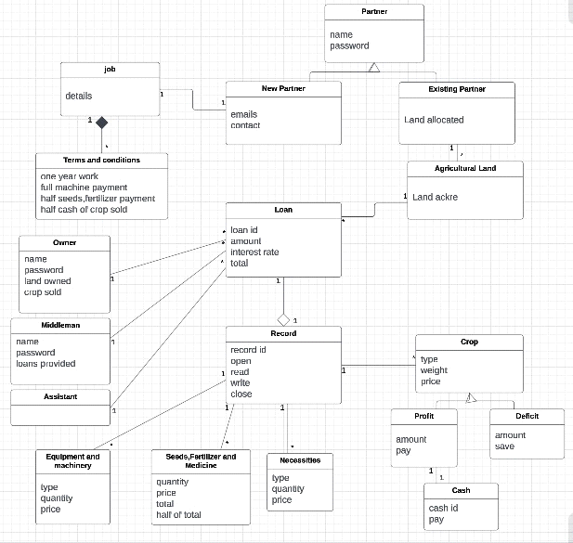

**Figure 8.2 (Object Diagram)**

**Sequence diagram**

Appoint Partner

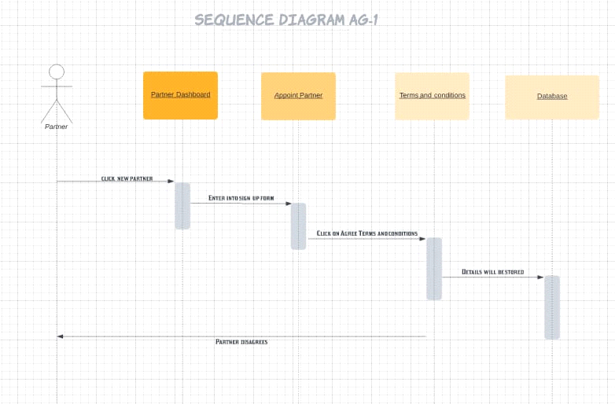

**Figure 8.3.1 (Sequence Diagram Ag-1)**

Allot the Land

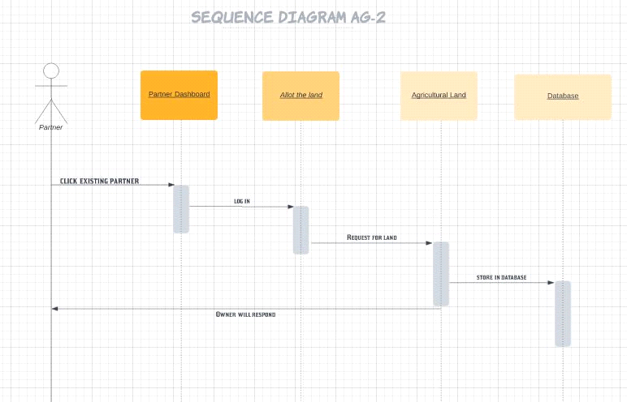

**Figure 8.3.2 (Sequence Diagram Ag-2)**

Provide Equipment and Machinery

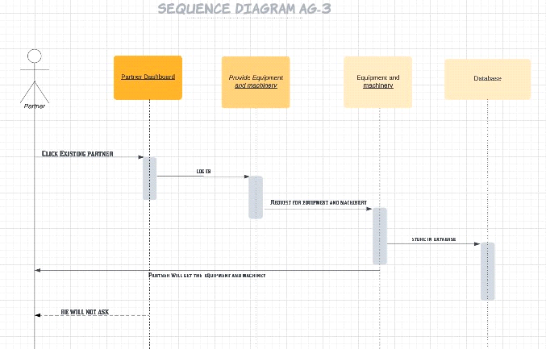

**Figure 8.3.3 (Sequence Diagram Ag-3)**

Calculate and request for loan

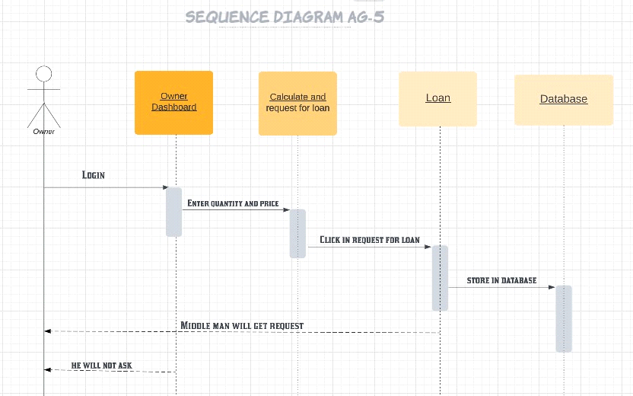

**Figure 8.3.4 (Sequence Diagram Ag-5)**

Provide seeds, fertilizers and medicines

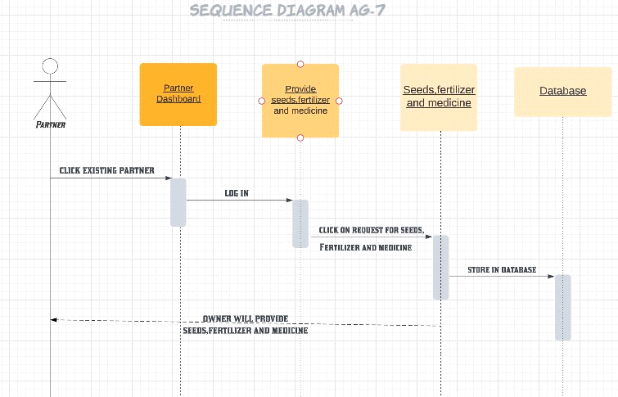

**Figure 8.3.5 (Sequence Diagram Ag-7)**

Provide Necessities of living to owner

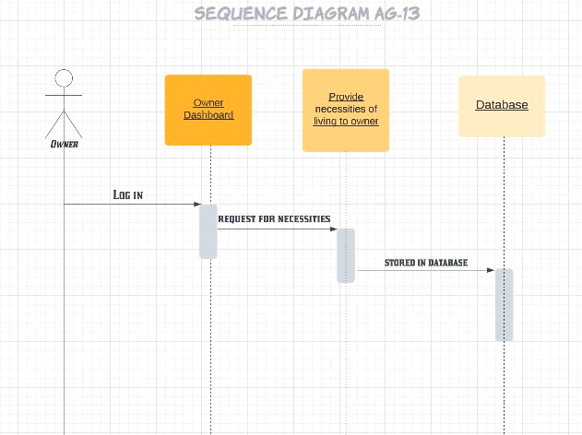

**Figure 8.3.6 (Sequence Diagram Ag-13)**

Gives Cash

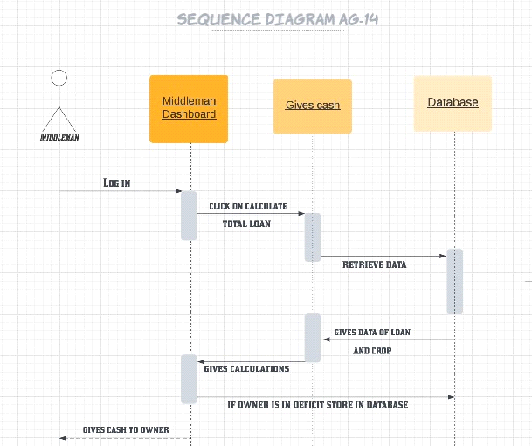

**Figure 8.3.7 (Sequence Diagram Ag-14)**

Maintains Record

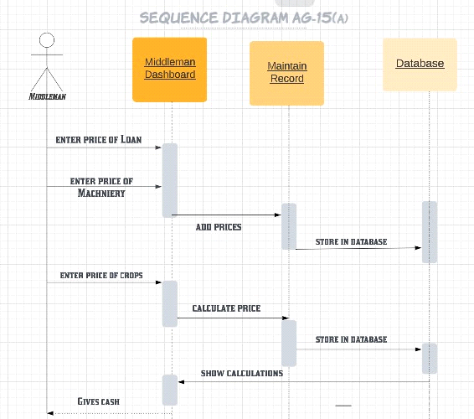

**Figure 8.3.8 (Sequence Diagram Ag-15(a))**

Maintains Record

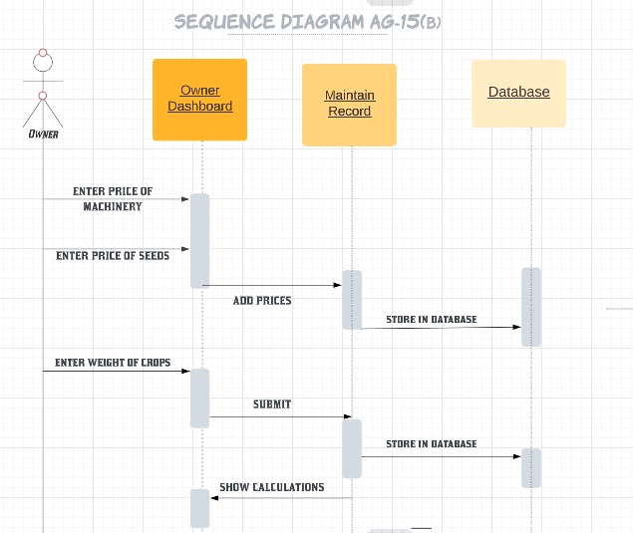

**Figure 8.3.9 (Sequence Diagram Ag-15(b))**

Calculate Partner’s Share

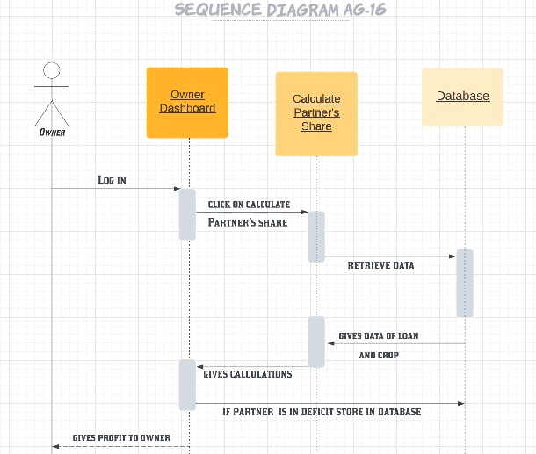

**Figure 8.3.10 (Sequence Diagram Ag-16)**

**Class Diagram**

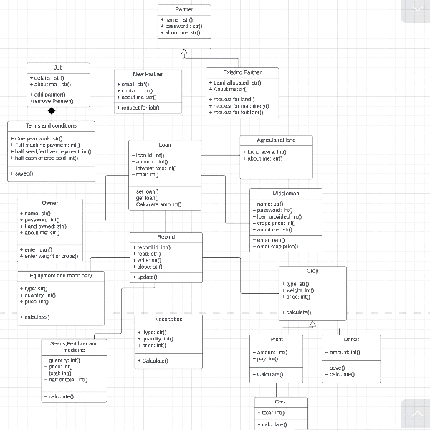

**Figure 8.4 (Class Diagram)**